Justin Fennell

Solution Description

**1. Assumptions, Main design decisions, and Error handling**

My program manages a student database with all basic functionality- create, read, update, delete. It uses a Swing based GUI which enables the end user to communicate with the database. The GUI consists of 4 labels, 3 text inputs, a combo box and button for processing requests. Error handling is implemented using try and catch blocks as well as if statements.

**2. Test cases table**

|  |  |  |  |  |
| --- | --- | --- | --- | --- |
| **Test case objective** | **Input values** | **Expected output** | **Actual output** | **Pass** |
| Check input  Id field | “sdsd” | Error message: “Please enter only numbers!” | Error message: “Please enter only numbers!” | passed |
| Check input  name field | “221” | Error message: “Must not contain numbers!” | Error message: “Must not contain numbers!” | passed |
| Check Inserting | Id: 1 Name: Steven  Major: CS | Message:  “Success!”  And inserts into Map | Message:  “Success!”  Value inserted | passed |
| Check delete  When id not exists | Id: 2 | Message:  “Student not in database!” | Message:  “Student not in database!” | passed |
| Check delete | Id: 1 | Message:  “Success!”  Item deleted | Message:  “Success!”  Item deleted | passed |
| Check find  When id does not exist | Id: 2 | Message:  “Student not in database!” | Message:  “Student not in database!” | passed |
| Check find | Id: 1 | Message with detailed info about student(id, name, major and GPA). | Message with detailed info about student(id, name, major and GPA). | passed |
| Check update  When id does not exist | Id: 2 | Message:  “Student not in database!” | Message:  “Student not in database!” | passed |
| Check update | Id: 1 | Show 2 Dialog boxes with combo box (Choose grade and choose credit), then show message “Course CS has been completed, Grade: A, Number of credits: 3”  Item updated | Showed 2 Dialog boxes with combo box (Choose grade and choose credit), than show message “Course CS has been completed, Grade: A, Number of credits: 3”  Item updated | passed |
| Check update  Press cancel in dialog boxes | Id: 1 | Item didn’t update | Item didn’t update | passed |
| Save in file | Map items | Map items saved in outData.txt, last line represents total student records and average GPA | Map items saved in outData.txt, last line represents total student records and average GPA | passed |
| Load from file | Text lines | Text file data restores map, except last line | Text file data restores map. | passed |
| Default GPA | Id: 3 | Student have not yet finished course – default GPA – 4.0 | Student have not yet finished course – default GPA – 4.0 | passed |

**3.** **Screen captures showing successful program compilation and test cases execution. Each screen capture should be properly labeled, clearly indicated what the screen capture represents.**

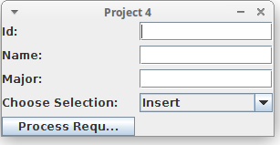

Picture 1 - Program main view with 4 labels, 3 text inputs combo-box and button.

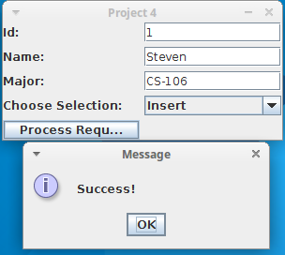

Picture 2 – Successful insertion to database

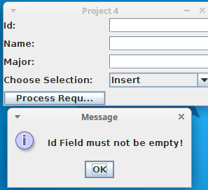

Picture 3 – Error if id Field is empty

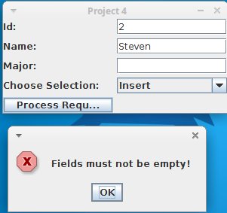

Picture 4 – All fields must have data if inserting to database

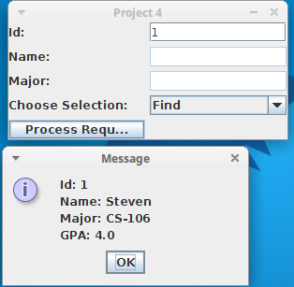

Picture 5 – If student didn’t finish course GPA = 4.0

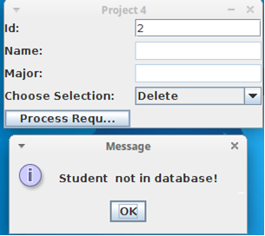

Picture 6 – If student ID is not in database

error will be shown

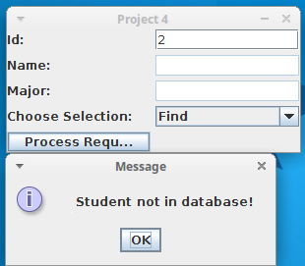

Picture 6.1 – Find field

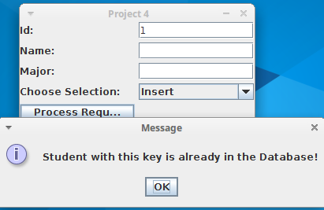

Picture 7 – If student ID is in database – error will be shown

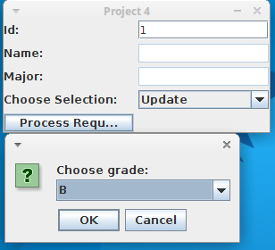

Picture 8 – Updating menu: Choosing grade

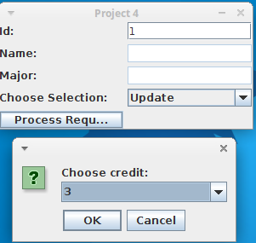

Picture 9 – Choosing credit

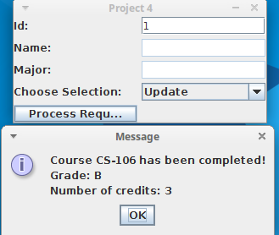

Picture 10 – Message after successful update.

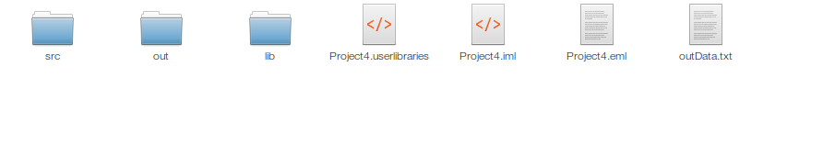Picture 11 – When exiting program, the file “outData.txt” is created.

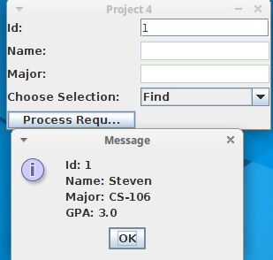

Picture 12 – After launching program file reads and restores the map

**4. Lessons learned from the project**

Increased experience using the Swing GUI. I created basic functions for handling a database (Create, Read, Delete, Update). I created my first Hash maps and learned how to save a hash map to a file and restore it from text files.